Урок английского языка в Музее Победы для инженерных классов
War Effort: Engineering
Рабочий лист для учителя

Introduction
Start in the Hall of Historical Verity
Ask the students to sum up the role of the Soviet Union in WWII based on what they have learnt in no more than 3 sentences, share and compare their ideas.
Hand out students’ worksheets and glossary templates (the latter is optional but could be used to ensure noting the vocabulary and/or structures that will later be used in the final production of the written work).
Task 1
Move on to the wall with the quotes by W. Churchill and F.D. Roosevelt in the Hall of Historical Verity.
Ask the students if any of their ideas are similar to the ones expressed in these quotations.
Organize work in 2 groups. Each prepares a rough translation of one of the quotes and then compares it to the original text.
Suggest students make a list of the vocabulary from the original quotes that they lacked in their translations and add the vocabulary they find most useful to the Glossary.
Group 1
Group 2
Follow-up discussion:
What are the key points that Churchill and Roosevelt make in their speeches on the role of the USSR in WWII?

Task 2
Go to the cases containing the Soviet propaganda posters in the Hall of Historical Verity. Discuss their key messages.
The students use the QR-code or the link below to see American and British propaganda posters and identify the ones addressing engineers. Discuss what messages they convey.
https://drive.google.com/drive/folders/1Rjv7l--qv_9P63PUrqi8pjK4LVug_609?usp=sharing
Organize work in pairs. Each student picks one of the posters to compare and contrast with the Soviet poster of their choice. The following plan is used:
• briefly describe both posters;
• say what they have in common;
• say in what way they are different;
• say which one you find more impressive and explain why.
The student’s partner comment on the talk mentioning:
- if they would add any information;
- if they agree with the conclusion; why/why not.

Task 3
Enter the Feat of the Army hall.
Read the inscription on the wall and discuss the role of engineers in winning the war.
The students compare their ideas with the following passage. They complete the text by inserting the appropriate words into the gaps.
During World War II, Army engineers placed floating and later fixed bridges across the rivers of Italy, France, and Germany, supporting hotly contested crossings of the Rapido, Roer, and Rhine rivers. Engineer troops prepared and developed beaches for assault landings, both in Europe and the Pacific. On the beaches of Normandy, engineer troops, operating under heavy enemy fire, cleared lanes for landing craft by destroying the mine-bearing steel structures that the Germans had implanted in the intertidal zone and bulldozed roads up the narrow draws through the cliffs lining the beaches. During the Battle of the Bulge, quick engineer actions destroyed critical bridges in the path of advancing German forces, slowing and diverting them while Allied forces regrouped. The engineers also opened road connections traversing the long wilderness reaches between the southern Canadian road net and interior Alaska and between British-ruled Assam Province in India and Yunnan Province in southwestern China.
(from https://www.usace.army.mil/)
The most useful vocabulary can be added to the Glossary.
Follow-up discussion:
What other function extremely important in times of war depends on the efforts of engineers and scientists?
It’s important to mention making weapons as it is the topic of the next three tasks.

Task 4
Students study the exhibition of weapons to find at least one weapon belonging to each of the categories:
- developed by Soviet engineers;
- captured as trophies;
- obtained through the Lend-Lease programme.
Find out what they know about the Lend-Lease policy.
Task 5
Students use the link to watch a short video lecture by the History channel to learn more about the Lend-Lease policy and work on their listening skills.
https://drive.google.com/file/d/1BOM5QwlB42EJNmCS5EaMUtZAIfaevZLL/view?usp=sharing
For each task 1 – 6, choose the best answer.
- The Lend-Lease Act initially regulated the conditions of weaponry provision between…
- the USA and the UK.
- the USA and the USSR.
- the UK and the USSR.
- According to the Neutrality Act, Britain…
- could not receive weapons from the US under any circumstances.
- could only get weapons from the US by paying cash and organizing transportation.
- could get weapons from the US on various terms.
- Why were some Americans against selling weapons to other countries?
- It could give unlimited power to the president.
- It would give more power to the president to participate in other countries’ wars.
- It could ruin the US economy.
- The Lend-Lease Act was devised as a way to…
- support war action without risking American citizens’ lives.
- avoid supporting any side in the war.
- earn more money for the state budget.
- As a result of signing the Act,
- only Great Britain received military support from the US.
- Great Britain, Russia and China received military support.
- a large number of countries received US military support.
- The Neutrality Act…
- prevented the USA from interfering till the end of the war.
- was cancelled when the Lend-Lease Act was signed.
- became irrelevant because of the attack on the USA.

Task 6
To prepare for the speaking part, the students need to identify the weapons.
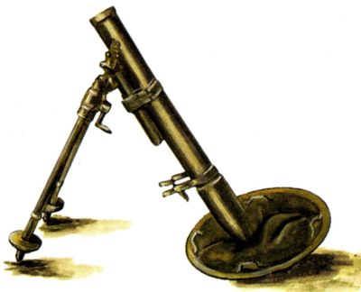 | 120-mm regimental mortar (PM-38, model of 1938)
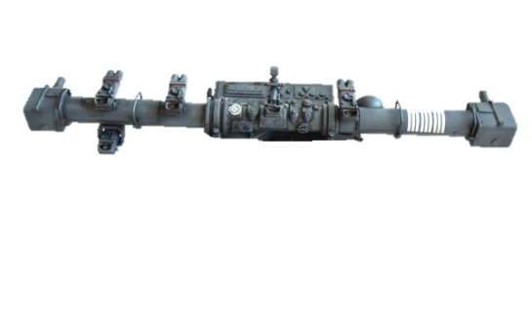 | Artillery rangefinder (KDO Mod.40 w/Sd.Anh 52)
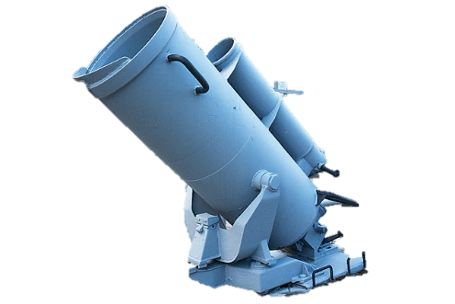 | Anti-submarine mortar with a depth charge
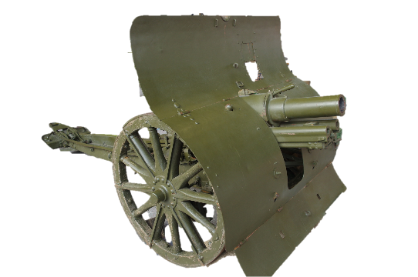 | 76-mm mountain gun M1909 with a limber
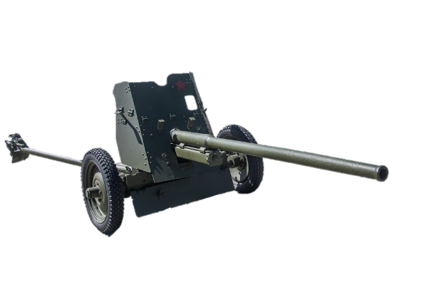 | 45-mm anti-tank gun M42 (model of 1942)

Then, they play a guessing game:
Student A has to describe a weapon without naming it.
Useful words and phrases:
ammunition
barrel
calibre
cannon
carriage
combined
compared to
employed by
equipped/fitted with
to fire
mobile
a (wide) range / have a range of
used by/for
weight / to weigh
wheel

Student B needs to guess which one is being described. Student B can ask clarification questions.
e.g. What is it used for? How much does it weigh?

After Student B identifies the right weapon, they swap roles.
Suggest the students look through tasks 4 to 6 again and work on their Glossary.

Task 7
Return to the Hall of Historical Verity.
Find the infographics titled Freedom for the West, Salvation for the East.
The final production task is writing a report based on the presented data with the addition of a section on the contribution of engineers based on what the students have learnt during the day.
The following plan is to be used:
– make an opening statement on the subject of your report;
– summarise the information by selecting and reporting the main features;
– make comparisons where relevant;
– give an overview of the engineers' contribution to the war effort;
– draw a conclusion.
It is recommended to assess the content (points covered, completeness), style and register (neutral or formal, appropriate linking), structure (paragraphs, logic and cohesion) and language (appropriate and correctly used vocabulary and grammar, spelling and punctuation).

Кейс 1 (базовый уровень)
The students are to write an informal letter using the information from the English version of the Museum’s website.
https://victorymuseum.ru/for-visitors/museum-for-china/en/
The task is as follows.
Use the information provided to answer the following letter you received from your English-speaking friend Debby.
…I’m really looking forward to my trip to Moscow! I’m especially interested in visiting the Victory Museum. As you may remember, I’m a fan of military history. How can I learn about the battles of the Great Patriotic War in the museum? Is there any information on the weaponry used during WWII? I’m going to travel with my parents and my 7-year-old brother. Will we be able to go on a guided tour?
By the way, I’ve decided to become an army engineer…
Write a letter to Debby. Use the information leaflet below to answer her questions. Ask three questions about her future profession.
Write 100 – 140 words. Remember the rules of letter writing.
The assessment is based on the National State Examination criteria.
Объём высказывания соответствует поставленной задаче: 90–154 слова
1. Решение коммуникативной задачи (Содержание) | Аспект 1. Ответ на вопрос 1 (упомянуты диорамы и панорамы музея)
 | Аспект 2. Ответ на вопрос 2 (упомянуты экспозиции на открытом воздухе)
 | Аспект 3. Ответ на вопрос 3 (упомянута экскурсия «Weapon of Victory»)
 | Аспект 4. Три вопроса о будущей профессии заданы
 | Аспект 5. Нормы вежливости соблюдены: ссылка на предыдущие контакты; благодарность за полученное письмо; надежда на последующие контакты
 | Аспект 6. Стилевое оформление выбрано правильно: обращение, завершающая фраза, подпись автора в соответствии с неофициальным стилем
 | ИТОГОВЫЙ БАЛЛ (максимальный балл – 2)
2. Организация | Логичность
 | Деление на абзацы
 | Средства логической связи
 | Обращение на отдельной строке
 | Завершающая фраза на отдельной строке
 | Подпись на отдельной строке
 | Адрес автора в правом верхнем углу (можно краткий)
 | Дата под адресом
 | ИТОГОВЫЙ БАЛЛ (максимальный балл – 2)
3. Языковое оформление текста. ИТОГОВЫЙ БАЛЛ (максимальный балл – 2) *
* 2 балла: орфографические и пунктуационные ошибки практически отсутствуют (допускается 1–2 лексико-грамматические ошибки И/ИЛИ 1–2 орфографические и пунктуационные ошибки)
1 балл: 3–4 лексико-грамматические ошибки И/ИЛИ имеется 3–4 орфографические и пунктуационные ошибки
0 баллов: 5 и более лексико-грамматических ошибок И/ИЛИ орфографических и пунктуационных ошибок

Кейс 2 (углубленный уровень)
This task is suitable for those aspiring to deal with academic, engineering or science-related translation.
The students need to read an article on the Soviet engineers’ contribution to winning the war and choose a passage for translation into English. Their work on the translation can be based on the following plan.
- Analyze the text:
- which grammar structures will you need to use?
- Which words and phrases do you need to look up?
- Are there any style and register peculiarities?
- Make a glossary of necessary vocabulary.
- Write a draft of the translation.
- Do error correction.
- Exchange translations with your peers, assess each other’s works and provide feedback. Consult with your English teacher. Edit the translation based on your peers’ and teacher’s recommendations.
Possible ways of organizing work and presenting results:
- All students translate the same passage. A contest for the best translation is organized.
- The whole article is divided equally among the students. The ultimate goal is to get a consistent translation of the article.

